**3D Text Plugin Asset for Unity3D**

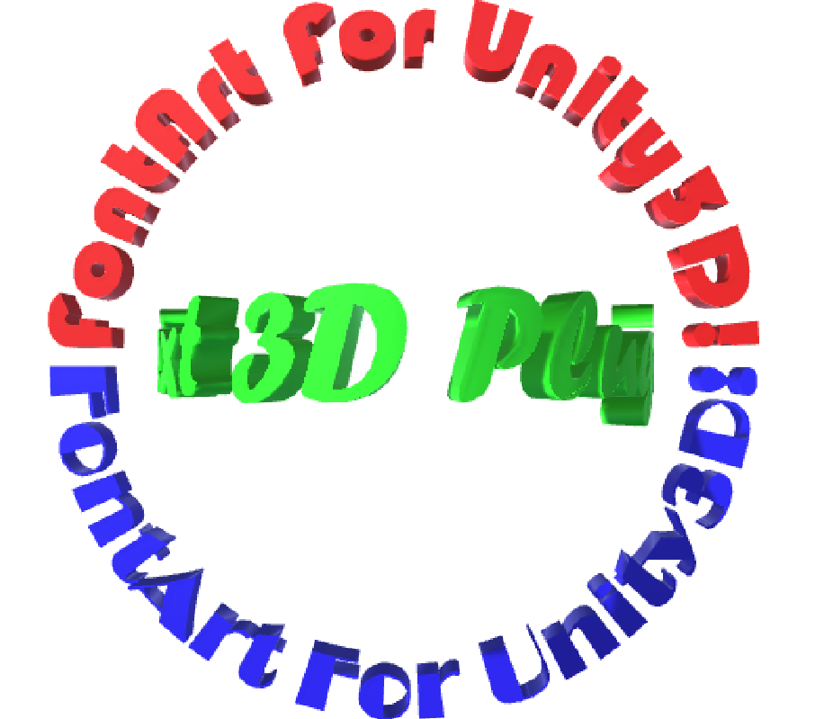

**Gbapyou@gmail.com**

**Summary**

This plugin allows Unity developers to easily create the 3D text with several fonts already installed in Windows OS. You can also easily curve the 3D Text model as you want. Also, you can export the 3D text models into .obj files for further use in several platforms.

**Required**

This plugin only works in Unity Editor mode in Windows Operating system.

For your convenience, it allows you to easily export 3D text models generated dynamically by this plugin into static mesh files (.obj file) for further use in several platforms.

And this plugin uses some unsafe code for communication with library (libFontArt.dll) which has been developed by publisher. So, you have to allow your project to use unsafe code by selecting the “Allow ‘unsafe’ Code” in Player Settings.

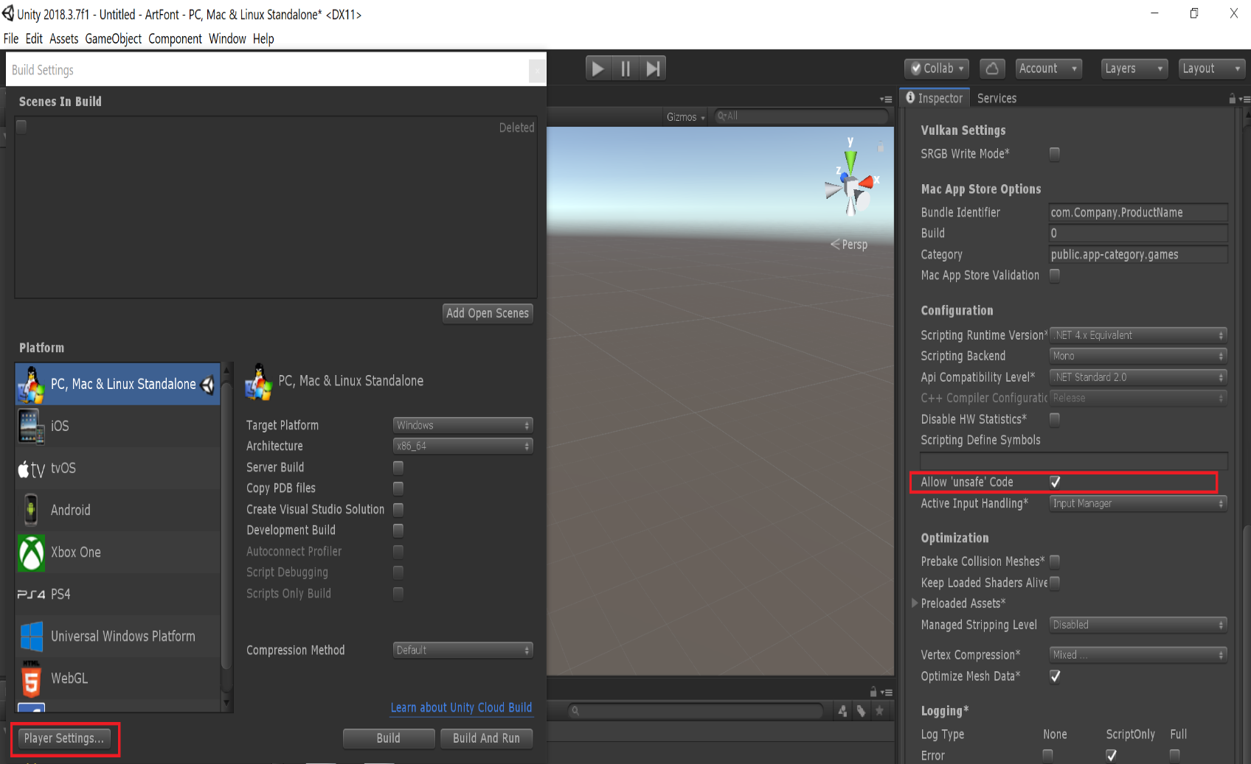

1. **Creating 3D Text model**

* Create an empty GameObject by selecting [GameObject/Create Empty] menu.
* Add a script called TextMeshPluginBehaviour.cs which is installed when you import this package. Then you can see a default 3D Text like below;

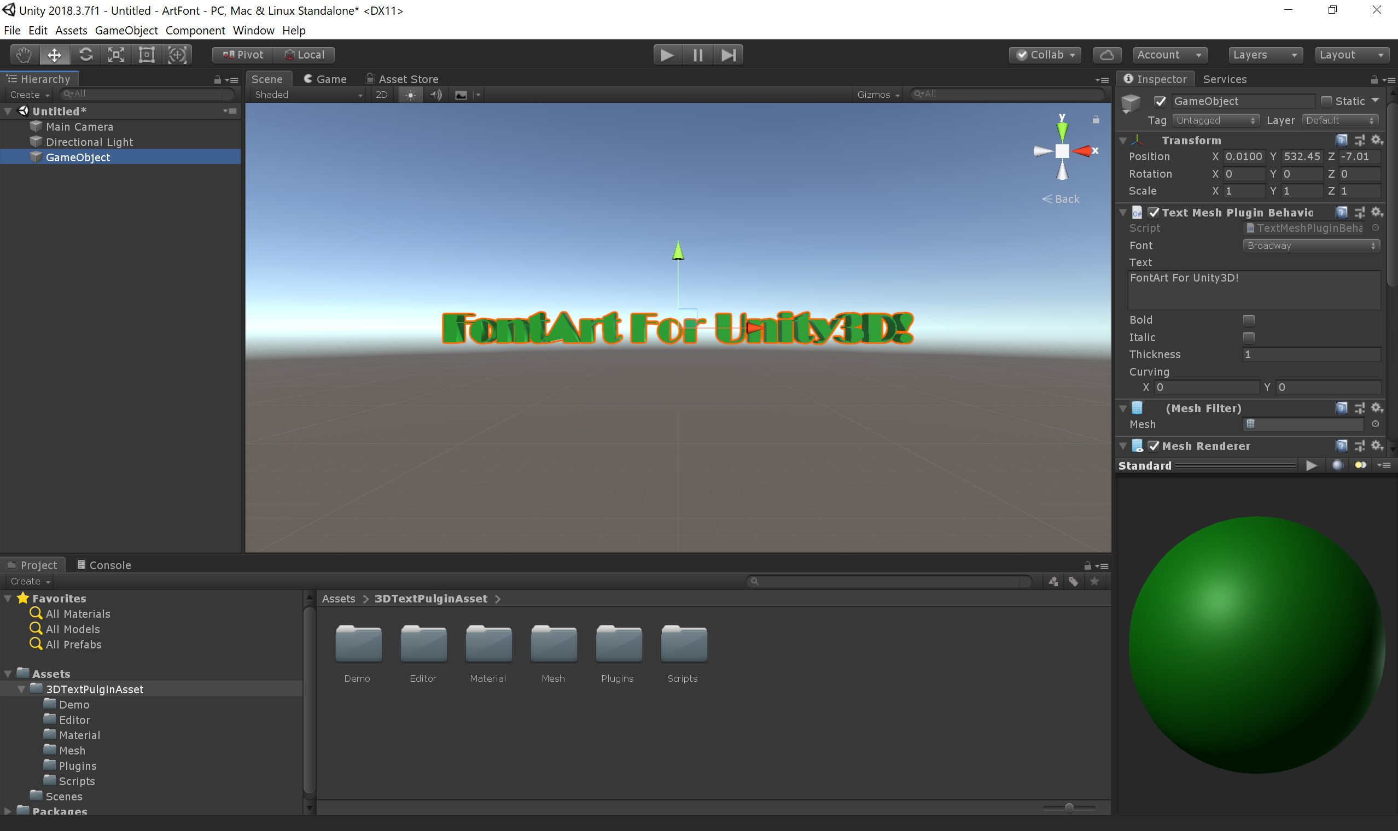

1. **Modifying 3D Text**

* **Selecting font**

After adding the script TextMeshPluginBehaviour.cs , you can see the dropdown list in Inspector that contains all font names installed in OS. Please select the font from the dropdown list in Inspector. Also, you can change the font property (Bold, Italic) in Inspector.

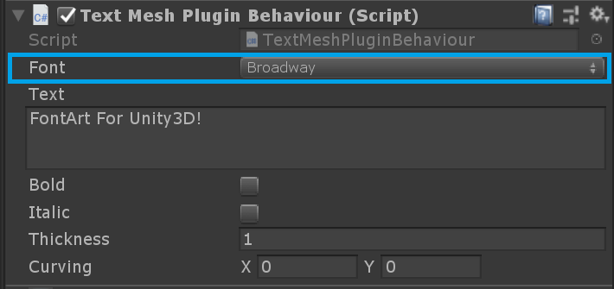

These are results you can instantly see when you select some fonts.

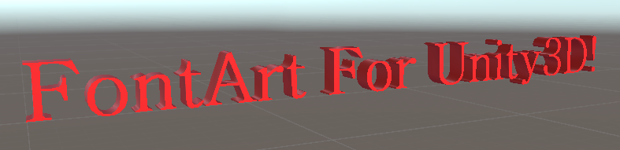

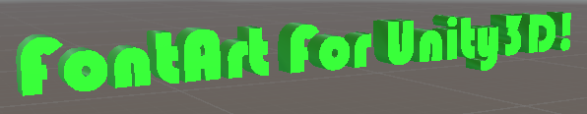

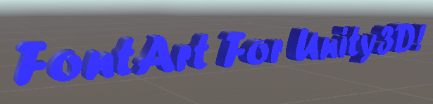

* **Changing content**

Please type a text string in Inspector. It allows you to type multi line text string.

You can see the 3D Text model being generated instantly according to your input.

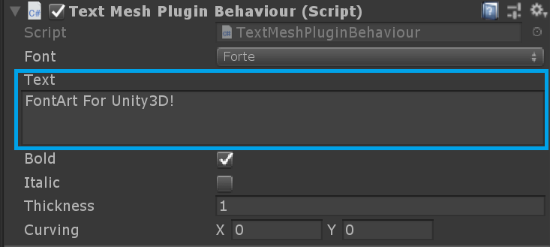

* **Curve the model as you want**

It allows you to easily curve 3D Text as you want by changing the parameters in Inspector.

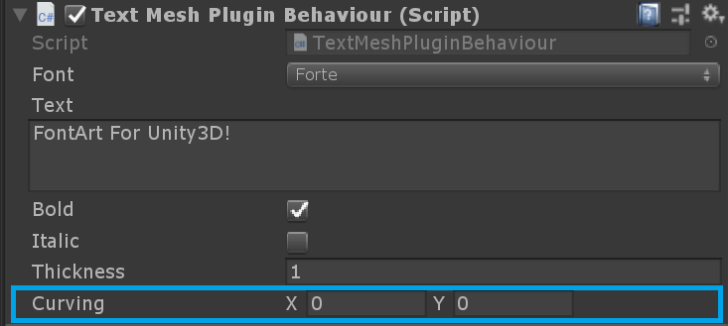

For example, when you change the x-value of the curving as 180 degree in Inspector, you can see the result like below.

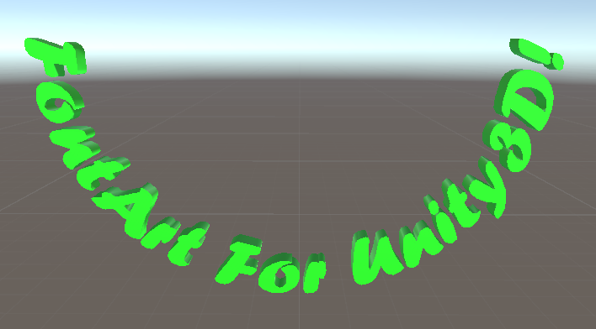

When the y-value is 180 degree, the result is like below;

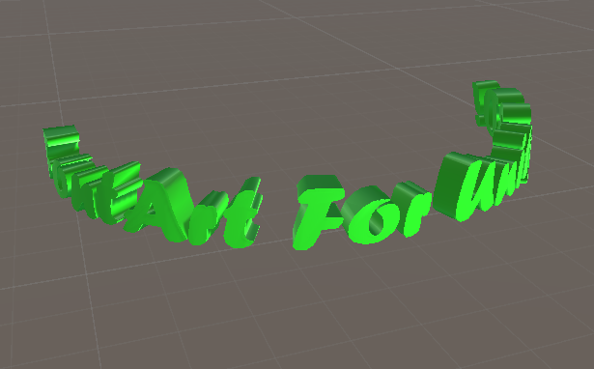

If you set x = 90, y = 90, you can see the result like below;

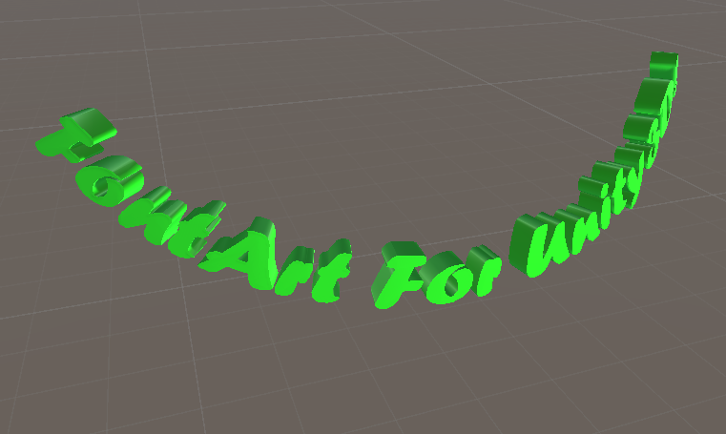

1. **Exporting.**

* It is very easy. Please select a GameObject you want to export, then select the menu [Window/Export as…].

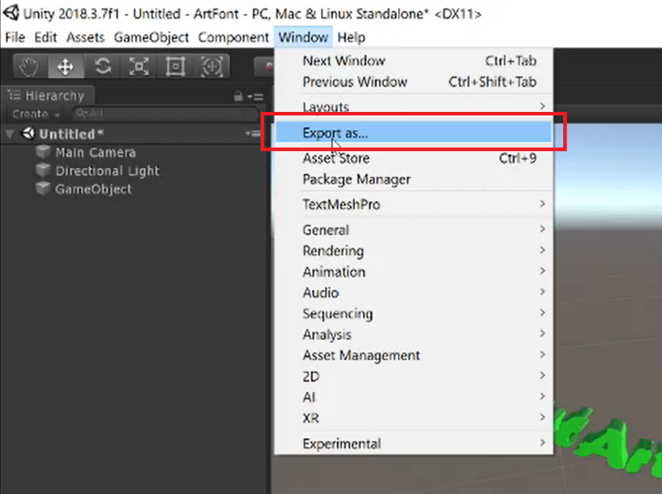

Then you can see the window like below;

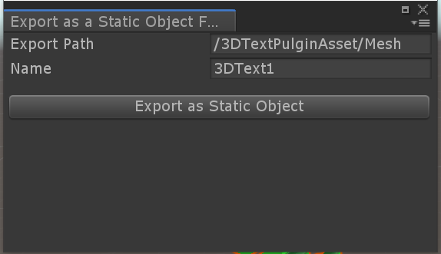

* Please enter a path and a name of the .obj file, then click on a button “Export as Static Object”.
* Finally, you have to refresh the folder you have selected, and you can see the .obj file generated.

**Contact**: [Gbapyou@gmail.com](mailto:Gbapyou@gmail.com)

**External Links:**

* YouTube: <https://youtu.be/MV9FSutD8Xo>
* GitHub: <https://github.com/Gbapy>